Proof #6
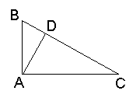
We start with the original triangle, now denoted ABC, and need only one additional construct - the altitude AD. The triangles ABC, BDA and ADC are similar which leads to two ratios:
AB/BC = BD/AB and AC/BC = DC/AC
Written another way these become
AB·AB = BD·BC and AC·AC = DC·BC
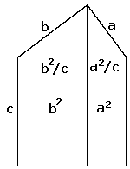
Summing up we get
The diagram on the right may serve two purposes. First, it gives an additional graphical representation to the present proof #6. In addition, it highlights the relation of the latter to proof #1.
AB·AB + AC·AC | = BD·BC + DC·BC
 | = (BD+DC)·BC = BC·BC.

